CS 305 Project One Template

Document Revision History

Version | Date | Author | Comments
1.0 | September 20th of 2025 | Jacob Lawrence Walker

Client



Instructions
Submit this completed vulnerability assessment report. Replace the bracketed text with the relevant information. In this report, identify your security vulnerability findings and recommend the next steps to remedy the issues you have found.

- Respond to the five steps outlined below and include your findings.
- Respond using your own words. You may also include images or supporting materials. If you include them, make certain to insert them in the relevant locations in the document.
- Refer to the Project One Guidelines and Rubric for more detailed instructions about each section of the template.

Developer
Jacob Lawrence Walker

1. Interpreting Client Needs
Determine your client’s needs and potential threats and attacks associated with the company’s application and software security requirements. Consider the following questions regarding how companies protect against external threats based on the scenario information:

- What is the value of secure communications to the company?
- Are there any international transactions that the company produces?
- Are there governmental restrictions on secure communications to consider?
- What external threats might be present now and in the immediate future?
- What modernization requirements must be considered, such as the role of open-source libraries and evolving web application technologies?

The assets with inherent risk in this software shall be classified as infrastructural data, customer data, company data, and abstract data. Infrastructural data refers to how the entirety of the system operates as in database structures, software interactions, software builds, and general operational functions. Customer data refers to any information relating to the customer as in addresses, social security numbers, bank account numbers, transaction histories, and more. Company data refers to employee information, trade secrets, procedures, etc. Abstract data refers to the trust in the company by any party, opinions directed at the company (employees, clients, media etc.).
Maintaining secure communications is paramount to prevent unauthorized access to any system, client, or company data. Due to the nature of data that will be exchanged between the clients and Artemis Financial not adhering to secure exchanges of information can result in significant financial loss, exposure or poisoning of data related to any of the above classifications, inhibition of expected usage of the system by any party, or complete shutdown of the system. Some realistic and common examples include the interception of login information by a third party resulting in access to funds by this third party, the misuse of queries causing a range of unintended effects from denial of service to exposure of sensitive data, and impersonation of any party by any party to pursue an agenda not in line with Artemis Financial or its clientele.
Under the assumption that Artemis Financial will be conducting internation business as well there are more considerations to be made. For strictly national (United States) business we have the Gramm-Leach-Bliley Act (GLBA) which is a federal law that requires Artemis Financial to explain how client data is shared and protected annually, allow for clientele to opt out of data sharing. More information regarding this and other related acts at the end of this document. It’s important to be compliant with the governing entity of every client, as in not doing so will limit the ability of Artemis Financial to do business with these companies and possibly result in foreign fines or sanctions. Please note the regulations and acts provided are not complete, as Artemis Financial has not provided locational data for its clients.
Bad actors are defined as groups that have motivations for targeting Artemis Financial, its systems and the clients it interacts with. Common bad actors will include general cybercriminals that are motivated by financial gain, state-sponsored entities, and hacktivists motivated by a political or social agenda. These bad actors will typically use flaws in applications to issue command injections, bypass authentication to impersonate any party, utilize sub-par access controls to hijack components of the system, harvesting exchanged data that is unencrypted, and social engineering techniques to achieve their goals. These bad actors are beginning to utilize Artificial Intelligence, which can increase the efficiency and effectiveness of hacking attempts. Artificial Intelligence is only becoming more prevalent and advanced, extra care needs to be taken when securing software applications as the processing speed and creativity of this tool can very well and rapidly identify flaws often overlooked by humans.
Special care needs to be taken with the RESTful API and its usage. As this will be the primary communication point between users and sensitive company data it will likely become a main target of bad actors. Proper measures need to be taken to ensure that unnecessary data is not provided in requests, requests are from authenticated users, authenticated users have the permissions to issue the requests, user input is validated and properly formatted, requests are limited in a way that prevents an unreasonable number of requests within a chunk of time, and requests/data are properly encrypted.
Supply chain attacks are also a relevant point of security that needs to be addressed. Supply chain attacks are defined as attacks that target the third-party components that are used. Modern applications are frequently being built on third-party packages that are open source, increasing the probability of an attack on this front. If a third-party package is compromised, the potential for Artemis Financials systems or related data to be compromised drastically increases. It’s important to consider whether using third-party packages is wise, and in using them to ensure that updates in response to vulnerabilities identified in them are applied frequently. Using outdated (even in reputable packages) is extremely unadvisable.

2. Areas of Security
Refer to the vulnerability assessment process flow diagram. Identify which areas of security apply to Artemis Financial’s software application. Justify your reasoning for why each area is relevant to the software application.

Input validation: all data and commands entering the system, especially in the API endpoints of the CRUDController should be considered untrusted. Verification that inputs are sanitized, formatted and within expectations before processing is critical because this can allow malicious data or commands to cause undesired or dangerous system behaviour. For example, SQL injections or cross-site injections can be utilized to allow bad actors to steal valuable data or damage system components.

API: being the primary channel of data exchange in this application, it’s critical to make sure that data is being exchanged through authenticated and authorized parties. Every request needs to have these checks, if else the opportunity for bad actors to modify or view sensitive data exists. For example, one flaw that results from improper checks is a broken object level authorization, where bad actors can access information by changing identification directly in the API request.

Cryptography: due to the nature of the information being exchanged by Artemis Financial (customer data, financial records, etc.) the exchange of data should be encrypted. Encryption prevents the interception of data traded between the user and system. Data should be encrypted while it is in transit, and while it is at rest. For example, login information that is not properly encrypted during an exchange (or at rest, for that matter) can be acquired via interception.

(irrelevant) Client/Server: because there is only code provided by the backend REST service, this portion is difficult to effectively lay out. I am restricted to static testing here.

Code Error: secure error handling is important as it prevents bad actors from taking advantage of unexpected application behaviour. Default or unrefined error messages may expose file trees and critical system components that would have not been available to a bad actor otherwise, allowing them to further their objective. Any specific error messages should be logged securely on the server, while a generic or non-specific message is presented to any other party. This ensures technical information is secure from these bad actors, and that any administrators may review and act accordingly to the errors later.

Code Quality: It’s important to have code that is easy to maintain and work with. Maintaining clean, organized, and documented code enables any flaws to stand out. Spaghetti code opens the door to errors that continue to be overlooked until they pose a problem, in other words potential security flaws that are not identified until they are a security breach. Audits are much easier with properly maintained code, and failures in the audits are easier to address when it’s easy to understand what’s happening.

Encapsulation: object-oriented programming considers the use of encapsulation, which is a basic principle that protects data integrity. This prevents users or bad actors from directly accessing data or commands relative to the system. In using methods that operate within the system itself, users and actors are prevented from understanding exactly how the system and its components operate.

3. Manual Review
Continue working through the vulnerability assessment process flow diagram. Identify all vulnerabilities in the code base by manually inspecting the code.

The highest risk areas of this application include the following files, CRUDController.java which is the API entry point, the application.properties which is its configuration file, and CRUD.java which includes database interactions.

CRUDController.java
- No input validation: “business_name”.
- No authentication: public endpoint, no verification of user existence
- No authorization: if a user is logged in, are they even allowed to access this?
- toString() can result in internal structure, leaking an applications design.

Application.properties
- filetypes are unrestricted: literally any filetype can be uploaded
- storage location: the directory appears exposed (i.e. “*/uploads”)
- file size: 200MB is a lot and could allow for a kind of DoS attack

CRUD.java
- mutable: content field should be declared as final, potential for an object to be edited after creation isn’t acceptable
- no validation: invalid, malicious, or massive amounts of data can be passed here

pom.xml
- Outdated and vulnerable framework: Spring Boot 2.2.2.RELEASE is several years outdated. There are known vulnerabilities in this version, information provided in the source section of this document
- Outdated and vulnerable crypto package: this package is over ten years old and has known vulnerabilities. More information is provided in the source section.
- Outdated security tool: OWASP DC plugin 5.3.0 is from six years ago.
- Outdated Java version (Java 8)

4. Static Testing
Run a dependency check on Artemis Financial’s software application to identify all security vulnerabilities in the code. Record the output from the dependency-check report. Include the following items:

- The names or vulnerability codes of the known vulnerabilities
- A brief description and recommended solutions provided by the dependency-check report
- Any attribution that documents how this vulnerability has been identified or documented previously

Priority | Dependency | Vulnerabilities | Description | Recommended Actions
VHIGH | bcprov-jdk15on-1.46.jar | CVE-2024-34447  CVE-2016-1000338  CVE-2016-1000342  CVE-2016-1000343  CVE-2024-29857  CVE-2016-1000341  CVE-2016-1000345  CVE-2024-30171  CVE-2020-15522  CVE-2020-0187  CVE-2023-33202  CVE-2020-26939  CVE-2023-33201  CVE-2015-7940  CVE-2018-5382  CVE-2013-1624  CVE-2016-1000346  CVE-2015-6644 | Improper certificate validations, improper and incomplete key validations, improper verification of cryptographic signature, weak key generation, excessive CPU and resource usage, timing attack vulnerability and leakages, private key and algorithm exposure with error codes, incomplete and incorrect and risky cryptographic algorithm choices. | Update
MED | hibernate-validator-6.0.18.Final.jar | CVE-2025-35036  CVE-2023-1932  CVE-2020-10693 | Improper input validation | Update and/or use proper input validations
HIGH | jackson-core-2.10.2.jar | CVE-2025-52999  CVE-2025-49128 | Potential log leakage exposing system information | Update
HIGH | jackson-databind-2.10.2.jar | CVE-2020-25649  CVE-2020-36518  CVE-2021-46877  CVE-2022-42003  CVE-2022-42004  CVE-2023-35116 | XML attack vulnerability, data integrity flaw, DoS vulnerability, deserialization of untrusted data | Update
LOW | log4j-api-2.12.1.jar | CVE-2020-9488 | Improper cert validate, vulnerability to MITM attacks | update
HIGH | logback-classic-1.2.3.jar | CVE-2023-6378  CVE-2021-42550 | Deserialization of untrusted data, DoS attack vulnerability, remote code execution | update
HIGH | logback-core-1.2.3.jar | CVE-2023-6378  CVE-2021-42550  CVE-2024-12798  CVE-2024-12801 | Deserialization of untrusted data, vulnerable to DoS attack, remote code execution | update
CRIT | snakeyaml-1.25.jar | CVE-2022-1471  CVE-2017-18640  CVE-2022-25857  CVE-2022-38749  CVE-2022-38751  CVE-2022-38752  CVE-2022-41854  CVE-2022-38750 | Improper input validation, deserialization of untrusted data, vulnerable to remote code execution and injection, multiple DoS vulnerabilities | update
CRIT* | spring-aop-5.2.3.RELEASE.jar | * CVE-2022-22965  CVE-2024-22259  CVE-2021-22118  CVE-2020-5421  CVE-2022-22950  CVE-2022-22971  CVE-2023-20861  CVE-2023-20863  CVE-2022-22968  CVE-2022-22970  CVE-2021-22060  CVE-2021-22096 | Remote code execution and injection vulnerability, untrusted URL redirect, improper privileges, vuln to privilege escalation, bypass RDG attack protections, SpEL vulnerability, DoS vulnerability | update
CRIT | spring-boot-2.2.4.RELEASE.jar | CVE-2023-20873  CVE-2022-27772  CVE-2023-20883 | Vuln to security bypass, directory hijacking, DoS attacks | update
CRIT | spring-boot-starter-web-2.2.4.RELEASE.jar | CVE-2023-20873  CVE-2022-27772  CVE-2023-20883 | Vuln to security bypass, DoS attacks | update
CRIT* | spring-context-5.2.3.RELEASE.jar | * CVE-2022-22965  CVE-2024-22259  CVE-2021-22118  CVE-2020-5421  CVE-2022-22950  CVE-2022-22971  CVE-2023-20861  CVE-2023-20863  CVE-2022-22968  CVE-2022-22970  CVE-2021-22060  CVE-2021-22096  CVE-2025-22233 | Vuln to remote code execution or injection, untrusted URL redirect, improper privileges, vuln to escalation, RFD protection bypass, vuln to DoS attacks, vuln to forged log insertion | update
CRIT* | spring-core-5.2.3.RELEASE.jar | * CVE-2022-22965  CVE-2025-41249  CVE-2025-41242  CVE-2024-22259  CVE-2021-22118  CVE-2020-5421  CVE-2022-22950  CVE-2022-22971  CVE-2023-20861  CVE-2023-20863  CVE-2022-22968  CVE-2022-22970  CVE-2021-22060  CVE-2021-22096 | Vuln to remote code execution and injection, improper authorization w/ security module, vuln to path traversal (conditional), untrusted URL redirect, improper privileges, RFD protection bypass, DoS vuln, log entry insertion | update
CRIT* | spring-expression-5.2.3.RELEASE.jar | * CVE-2022-22965  CVE-2024-22259  CVE-2021-22118  CVE-2020-5421  CVE-2022-22950  CVE-2022-22971  CVE-2023-20861  CVE-2023-20863  CVE-2024-38808  CVE-2022-22968  CVE-2022-22970  CVE-2021-22060  CVE-2021-22096 | Vuln to remote code execution and injection, untrusted URL redirect, improper privileges (escalation possible), RFD protection bypass, privilege management, no resource limits (DoS vuln,), expression language injection vuln, insertion of log entry insertion vuln | update
CRIT* | spring-web-5.2.3.RELEASE.jar | CVE-2016-1000027  * CVE-2022-22965  CVE-2024-22243  CVE-2024-22262  CVE-2024-22259  CVE-2021-22118  CVE-2025-41234  CVE-2020-5421  CVE-2022-22950  CVE-2022-22971  CVE-2023-20861  CVE-2023-20863  CVE-2022-2296  CVE-2022-22970  CVE-2021-22060  CVE-2021-22096 | Vuln to remote code execution, vuln to RCE injection, DoS attack vuln, untrusted URL redirect, improper privileges, privilege escalation vuln, RFD vuln (conditional), DoS vuln, improper error handling  Deserialization of untrusted data, RCE vuln, DoS attack vuln, redirection to untrusted site potential, improper privilege management. (escalation), RFD protection bypass, | update
CRIT* | spring-webmvc-5.2.3.RELEASE.jar | * CVE-2022-22965  CVE-2024-38816  CVE-2024-22259  CVE-2021-22118  CVE-2020-5421  CVE-2022-22950  CVE-2022-22971  CVE-2023-20861  CVE-2023-20863  CVE-2022-22968  CVE-2022-22970  CVE-2021-22060  CVE-2021-22096 | Vuln to RCE and injection, path traversal (conditional), vuln to untrusted URL redirects, improper privilege (escalation), RFD protection bypass, DoS vuln from unmanaged resource use, log entry insertion  Deserialization of untrusted data, code injection vuln, untrusted URL redirect vuln, improper privileges, DoS vuln (improper resource limits), SpEL injection vuln | update
CRIT* | tomcat-embed-core-9.0.30.jar | * CVE-2020-1938  CVE-2024-50379  CVE-2024-52316  CVE-2024-56337  * CVE-2025-24813  CVE-2025-31651  CVE-2025-49124  CVE-2020-11996  CVE-2020-13934  CVE-2020-13935  CVE-2020-17527  CVE-2021-25122  CVE-2021-41079  CVE-2022-29885  CVE-2022-42252  * CVE-2023-44487  CVE-2023-46589  CVE-2024-24549  CVE-2024-34750  CVE-2024-38286  CVE-2025-48988  CVE-2025-48989  CVE-2025-49125  CVE-2025-52434  CVE-2025-52520  CVE-2025-53506  CVE-2025-46701  CVE-2020-9484  CVE-2021-25329  CVE-2021-30640  CVE-2025-55668  CVE-2024-23672  CVE-2022-34305  CVE-2023-41080  CVE-2021-24122  CVE-2021-33037  CVE-2023-42795  CVE-2023-45648  CVE-2024-21733  CVE-2024-54677  CVE-2019-17569  CVE-2020-1935  CVE-2020-13943  CVE-2023-28708  CVE-2021-43980 | Improper trust level of certain connections, RCE vulnerability (injection), authentication bypass vuln,, vuln to partial PUT request causing information exposure or injection, DoS attack vuln from unmanaged/unrestricted resources, unauthorized information exposure, improper input validation, loop without exit (DoS potential), request smuggling with reverse proxy, improper error handling, file tree exposure via deserialization, authorization bypass, untrusted URL redirect,  Improper trust levels for certain connections, authentication bypass potentials, remote code execution vuln, permissions bypass vuln, DoS vuln from unrestricted and mismanaged resource allocation, information leaks to unauthorized actor via request header reuse, rapid reset attack vuln cause DoS, input validation vuln, | update
CRIT* | tomcat-embed-websocket-9.0.30.jar | * CVE-2020-1938  CVE-2024-50379  CVE-2024-52316  CVE-2024-56337  * CVE-2025-24813  CVE-2025-31651  CVE-2025-49124  CVE-2020-8022  CVE-2020-11996  CVE-2020-13934  CVE-2020-13935  CVE-2020-17527  CVE-2021-25122  CVE-2021-41079  CVE-2022-29885  CVE-2022-42252  * CVE-2023-44487  CVE-2023-46589  CVE-2024-24549  CVE-2024-34750  CVE-2024-38286  CVE-2025-48988  CVE-2025-48989  CVE-2025-49125  CVE-2025-52434  CVE-2025-52520  CVE-2025-53506  CVE-2025-46701  CVE-2020-9484  CVE-2021-25329  CVE-2021-30640  CVE-2025-55668  CVE-2024-23672  CVE-2022-34305  CVE-2023-41080  CVE-2021-24122  CVE-2021-33037  CVE-2023-42795  CVE-2023-45648  CVE-2024-21733  CVE-2024-54677  CVE-2019-17569  CVE-2020-1935  CVE-2020-13943  CVE-2023-28708  CVE-2021-43980 | RCE execution (injection) via file upload component, authentication bypass chance, incorrect permissions, DoS attack vuln, infinite loop, information leak via reusing HTTP request headers, improper input validation, DoS vuln from unrestricted resource management, smuggling info via inconsistent HTTP request interp, deserialization of untrusted data,  Improper privilege management (escalation), RCE attack vuln, authentication bypass, code execution/information disclosure/content injection via partial PUT request, improper default permissions, DoS vuln due to unreleased memory or mismanaged allocations, infinite loops, information exposure to unauthorized actors, improper input validation, repid reset vuln (DoS type), | update

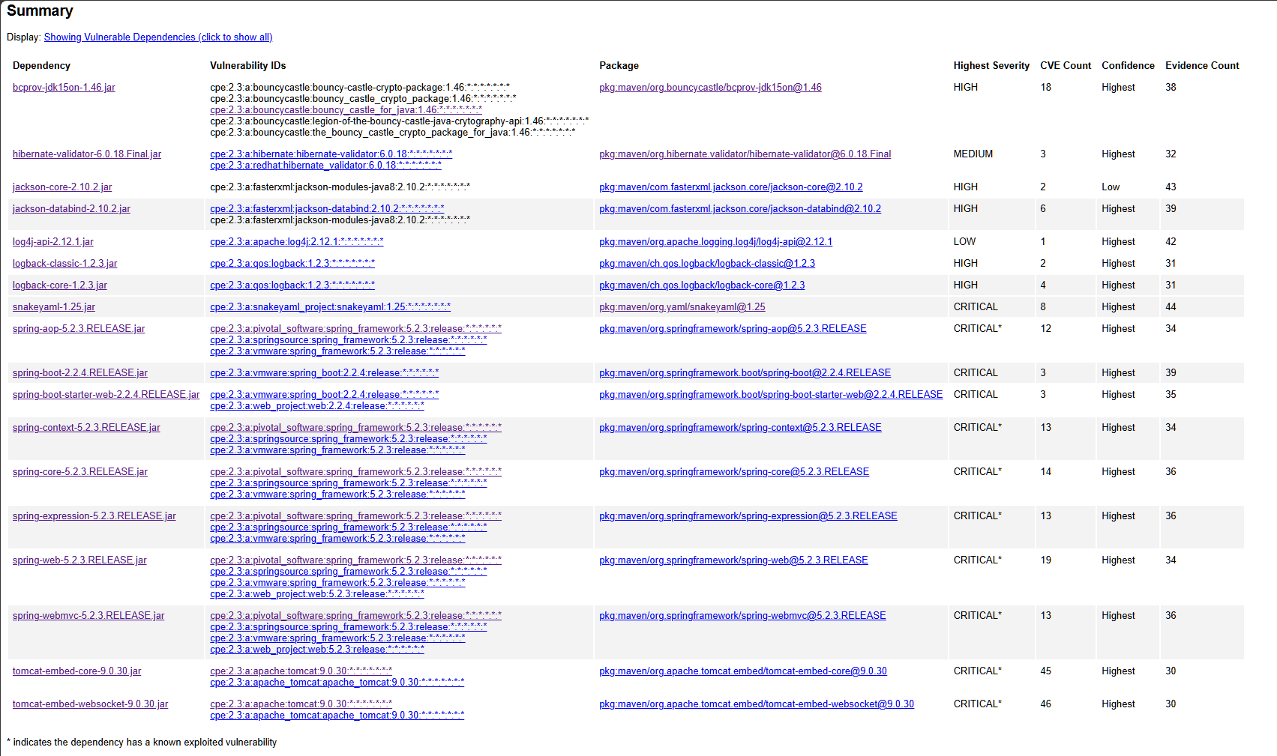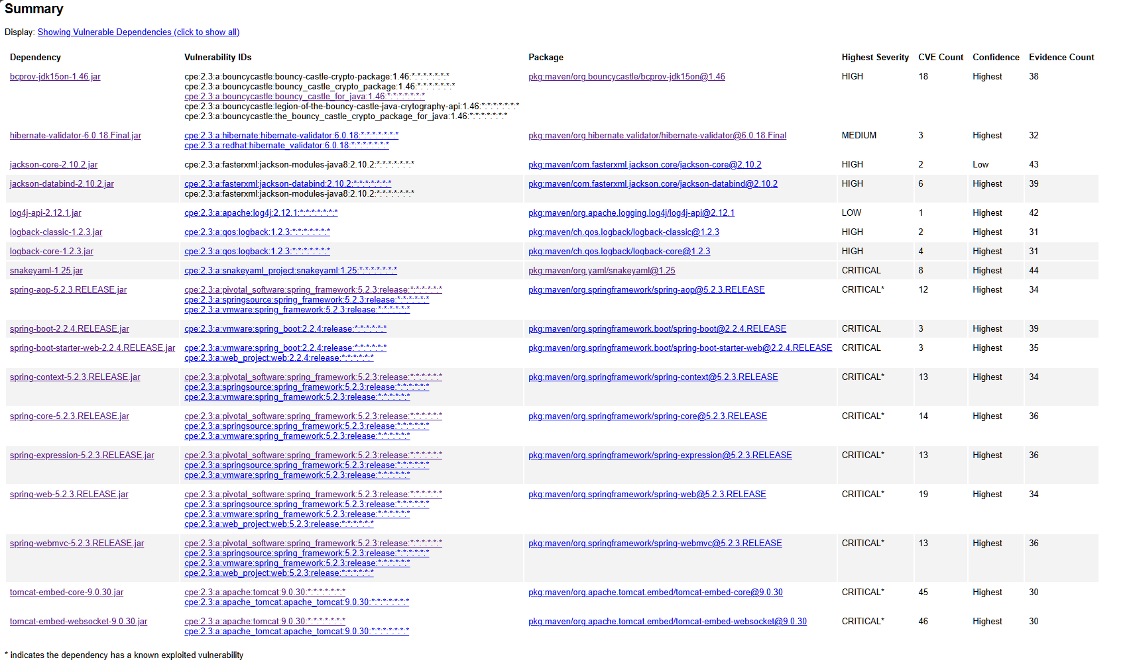
I updated the OWASP DC plugin to the most recent version (12.1.0) prior to running.

5. Mitigation Plan
Interpret the results from the manual review and static testing report. Then identify the steps to mitigate the identified security vulnerabilities for Artemis Financial’s software application.

Top priority should be made to update the parent POM in pom.xml to a modern Spring Boot. Java should also be updated from 1.8 to a modern version. Bouncy castle needs to be updated. This should resolve multiple remote code injections and cryptographic based vulnerabilities. These are primarily supply chain issues which are easy fixes with an update and will resolve nearly every vulnerability in the report.
Requiring valid authentication at every API endpoint will prevent unauthorized access to all information types as well as prevent the modification or poisoning of data.
Application.properties should have a whitelist indicating allowed filetypes, and perhaps a smaller file size to prevent RCE and DoS attacks. HTTPS should be enforced as well.
Validation annotations should be added to the input parameters in CRUDcontroller.java will improve susceptibility to injection-based attacks. The CRUD.java class should have immutable fields (private final) which will also help with this.

Government-related Acts

DAD, T. K. (Acting, & Nguyen, S. T. (2024, April 3). Gramm-Leach-Bliley Act. Federal Trade Commission. https://www.ftc.gov/legal-library/browse/statutes/gramm-leach-bliley-act

H.R.3763 - 107th Congress (2001-2002): Sarbanes-Oxley Act of 2002 | Congress.gov | Library of Congress. (n.d.). https://www.congress.gov/bill/107th-congress/house-bill/3763

Legal text. General Data Protection Regulation (GDPR). (2024, April 22). https://gdpr-info.eu/

Vulnerabilities sources

Maven Repository: Org.springframework.boot » spring-boot » 2.2.2.release. Maven Repository. (n.d.). https://mvnrepository.com/artifact/org.springframework.boot/spring-boot/2.2.2.RELEASE

Maven Repository: Org.bouncycastle » bcprov-JDK16 » 1.46. Maven Repository. (n.d.-a). https://mvnrepository.com/artifact/org.bouncycastle/bcprov-jdk16/1.46

